DAY 5

Day 5 -1

package day5;

import org.openqa.selenium.By;

import org.openqa.selenium.WebDriver;

import org.openqa.selenium.WebElement;

import org.openqa.selenium.chrome.ChromeDriver;

import org.openqa.selenium.chrome.ChromeOptions;

import org.openqa.selenium.interactions.Actions;

public class drag {

public static void main(String[] args) throws InterruptedException

{

System.setProperty("webdriver.chrome.driver","C:\\ChromeDriver\\chromedriver.exe");

ChromeOptions co = new ChromeOptions();

co.addArguments("--remote-allow-origins=*");

WebDriver driver = new ChromeDriver(co);

driver.get("https://demoqa.com/droppable/");

Actions a= new Actions(driver);

WebElement source =driver.findElement(By.id("draggable"));

WebElement dest = driver.findElement(By.id("droppable"));

a.clickAndHold(source).release(dest).build().perform();

a.dragAndDrop(source,dest).build().perform();

}

}

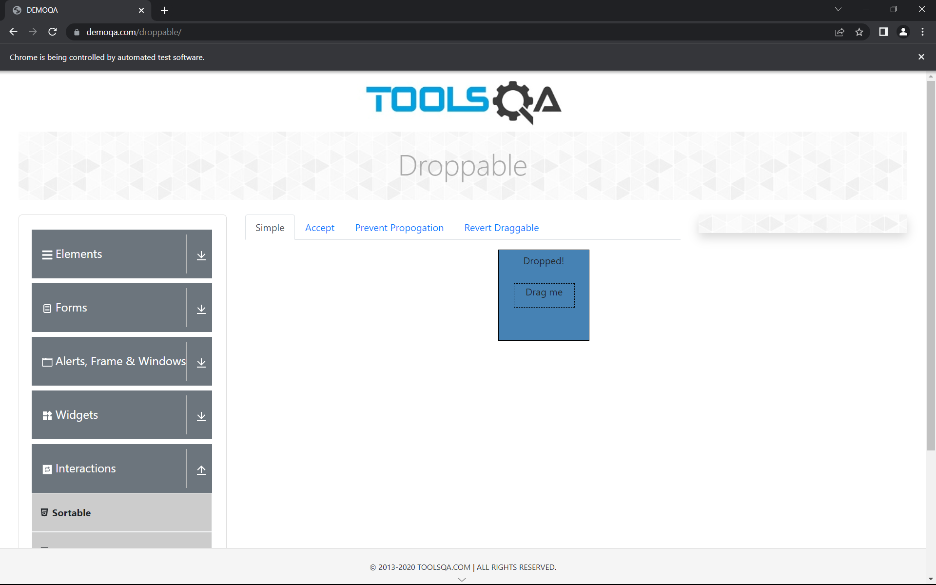

DAY 5-2:

package day5;

import org.openqa.selenium.By;

import org.openqa.selenium.WebDriver;

import org.openqa.selenium.WebElement;

import org.openqa.selenium.chrome.ChromeDriver;

import org.openqa.selenium.chrome.ChromeOptions;

import org.openqa.selenium.interactions.Actions;

import io.github.bonigarcia.wdm.WebDriverManager;

public class d52 {

public static void main(String[] args) throws InterruptedException

{

// WebDriverManager.chromedriver().setup();

System.setProperty("webdriver.chrome.driver","C:\\ChromeDriver\\chromedriver.exe");

ChromeOptions co = new ChromeOptions();

co.addArguments("--remote-allow-origins=*");

WebDriver driver = new ChromeDriver(co);

driver.get("https://demoqa.com/droppable/");

Actions a= new Actions(driver);

WebElement source =driver.findElement(By.id("draggable"));

WebElement dest = driver.findElement(By.id("droppable"));

a.clickAndHold(source).release(dest).build().perform();

a.dragAndDrop(source,dest).build().perform();

}

}



DAY 5-3:

package day5;

import org.openqa.selenium.Alert;

import org.openqa.selenium.By;

import org.openqa.selenium.WebDriver;

import org.openqa.selenium.WebElement;

import org.openqa.selenium.chrome.ChromeDriver;

import org.openqa.selenium.chrome.ChromeOptions;

public class d53 {

public static void main(String[] args)

{

System.setProperty("webdriver.chrome.driver","C:\\ChromeDriver\\chromedriver.exe");

ChromeOptions co= new ChromeOptions();

co.addArguments("--remote-allow-origins=*");

WebDriver driver= new ChromeDriver(co);

driver.get("https://demo.guru99.com/test/delete_customer.php");

WebElement txt= driver.findElement(By.xpath("/html/body/form/table/tbody/tr[2]/td[2]/input"));

WebElement submit=driver.findElement(By.name("submit"));

txt.sendKeys("401");

submit.click();

Alert alert1=driver.switchTo().alert();

alert1.dismiss();

txt.clear();

txt.sendKeys("402");

submit.click();

Alert alert2= driver.switchTo().alert();

alert2.accept();

Alert alert3=driver.switchTo().alert();

String a= alert3.getText();

alert3.accept();

System.out.println();

}

}

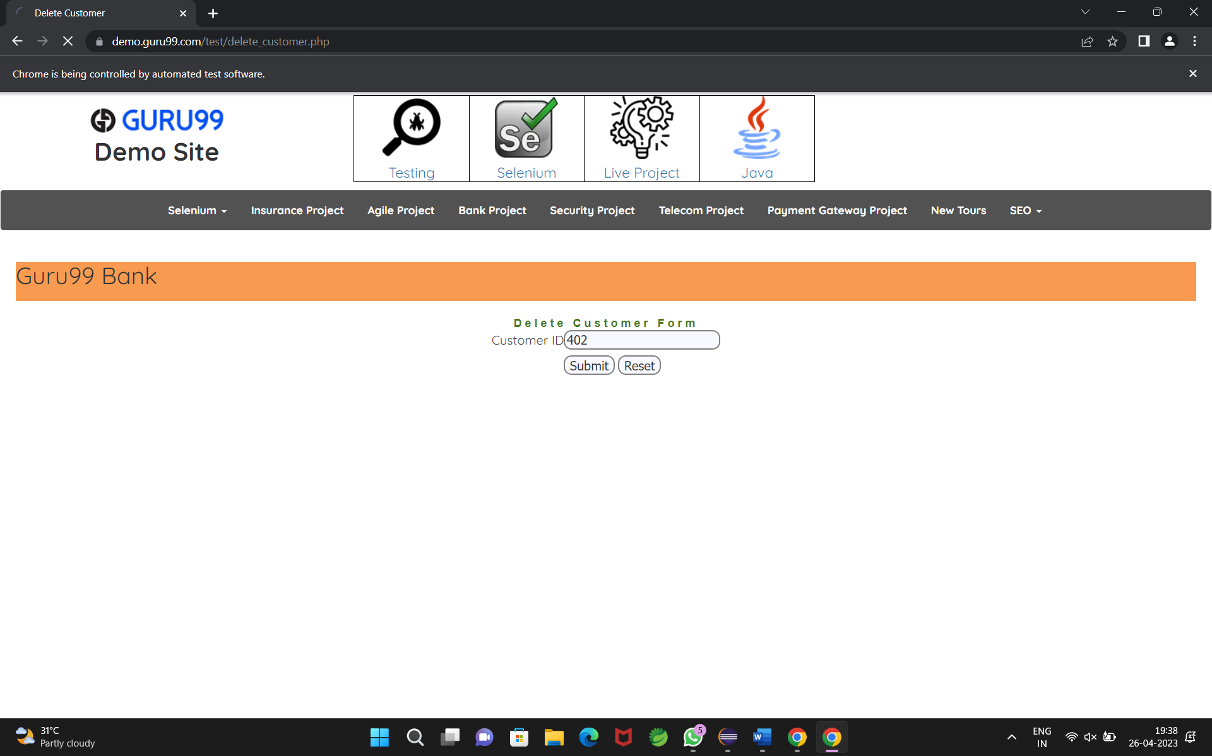

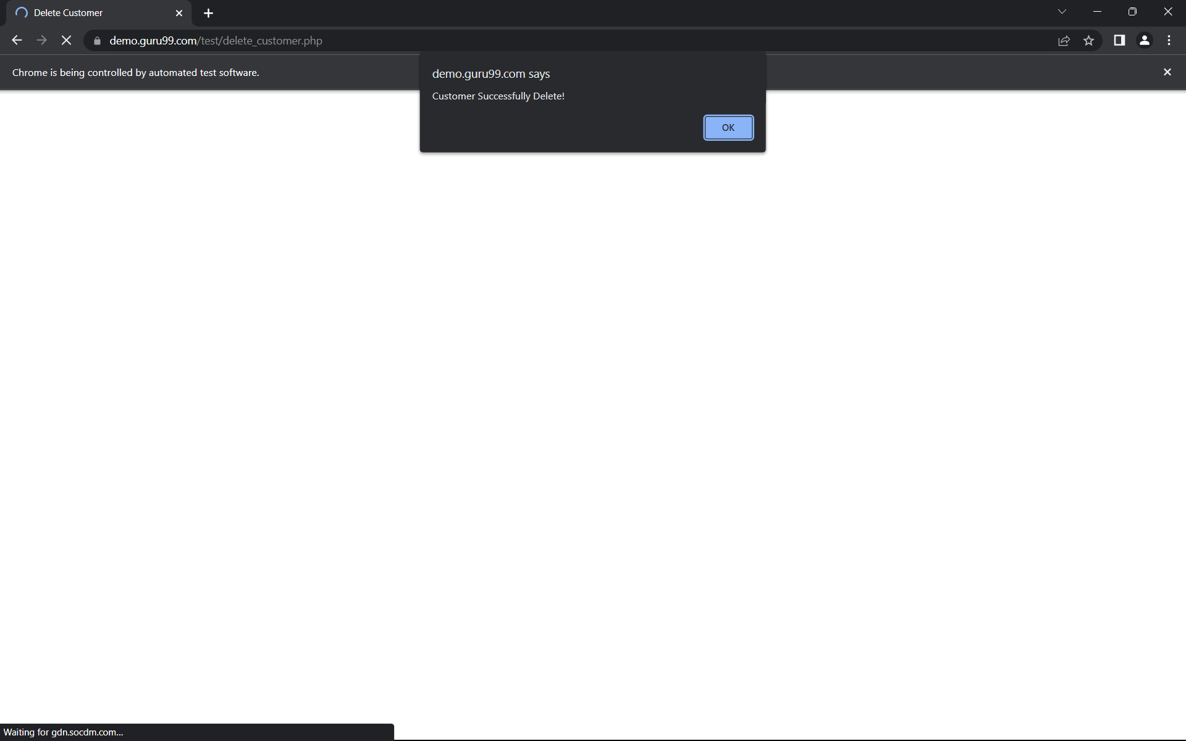

DAY 5- 4:

package day5;

import org.openqa.selenium.By;

import org.openqa.selenium.JavascriptExecutor;

import org.openqa.selenium.Keys;

import org.openqa.selenium.WebDriver;

import org.openqa.selenium.WebElement;

import org.openqa.selenium.chrome.ChromeDriver;

import org.openqa.selenium.chrome.ChromeOptions;

public class d55 {

public static void main(String[] args) throws InterruptedException

{

System.setProperty("webdriver.chrome.driver","C:\\ChromeDriver\\chromedriver.exe");

ChromeOptions co= new ChromeOptions();

co.addArguments("--remote-allow-origins=*");

WebDriver driver= new ChromeDriver(co);

driver.get("https://WWW.abhibus.com/bus-ticket-booking");

WebElement leaving_from = driver.findElement(By.xpath("//*[@id=\"source\"]"));

// leaving_from.sendKeys("chennai");

leaving_from.sendKeys("Chennai");

Thread.sleep(3000);

leaving_from.sendKeys(Keys.ENTER);

WebElement going_to = driver.findElement(By.xpath("//*[@id=\"destination\"]"));

// going_to.sendKeys("coimbatore");

going_to.sendKeys("Coimbatore");

Thread.sleep(3000);

going_to.sendKeys(Keys.ENTER);

WebElement datepicker = driver.findElement(By.xpath("//*[@id=\"datepicker1\"]"));

datepicker.click();

JavascriptExecutor js= (JavascriptExecutor) driver;

js.executeScript("arguments[0].setAttribute('value','02-05-2023')",datepicker);

WebElement search_btn = driver.findElement(By.xpath("//*[@id=\"seo_search_btn\"]"));

search_btn.click();

}

}

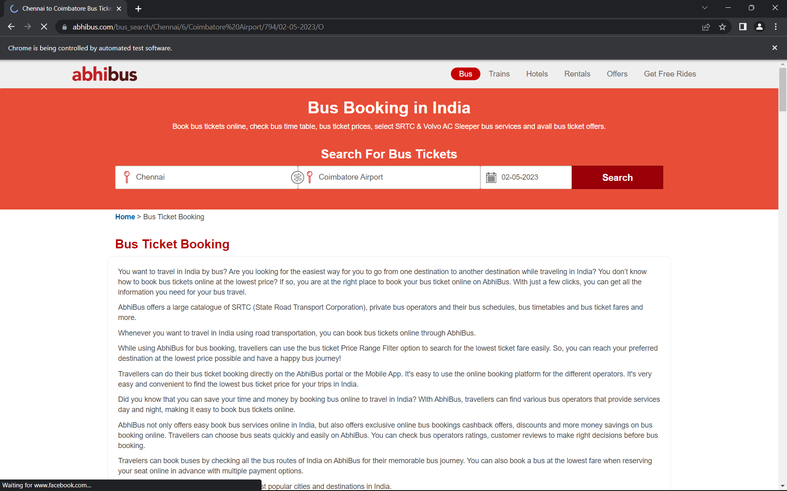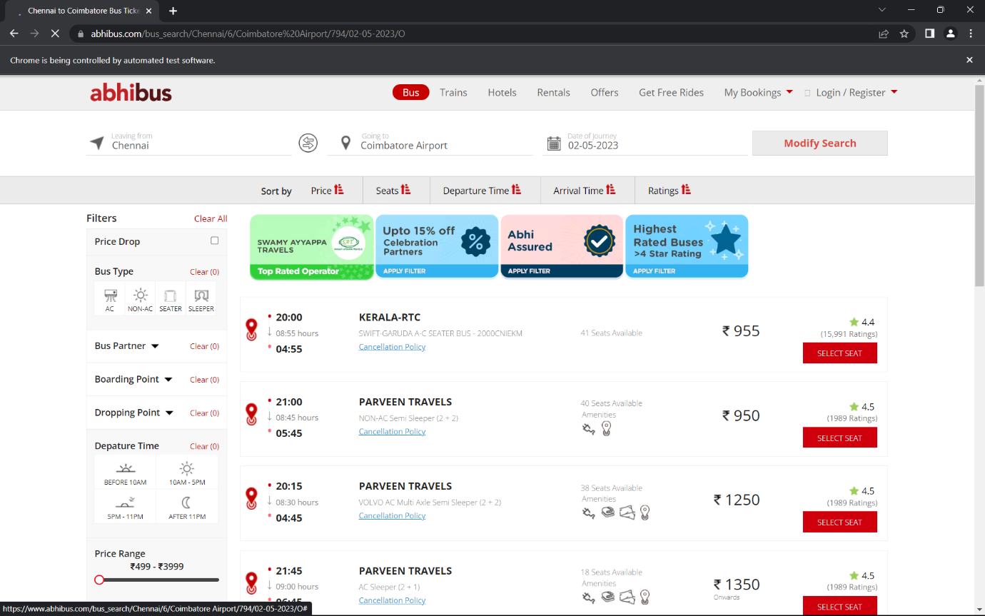

DAY 5-5:

package day5;

import java.util.Set;

import org.openqa.selenium.By;

import org.openqa.selenium.Keys;

import org.openqa.selenium.WebDriver;

import org.openqa.selenium.WindowType;

import org.openqa.selenium.chrome.ChromeDriver;

import org.openqa.selenium.chrome.ChromeOptions;

import io.github.bonigarcia.wdm.WebDriverManager;

public class d54{

public static void main(String[]args) {

WebDriverManager.chromedriver().setup();

ChromeOptions co=new ChromeOptions();

co.addArguments("--remote-allow-origins=*");

WebDriver driver = new ChromeDriver(co);

driver.manage().window().maximize();

driver.get("https://www.google.com/");

driver.findElement(By.name("q")).sendKeys("Apple");

driver.findElement(By.name("q")).sendKeys(Keys.ENTER);

String parent = driver.getWindowHandle();

System.out.println(parent);

System.out.println(driver.getTitle());

driver.switchTo().newWindow(WindowType.TAB);

driver.get("https://www.google.com/");

driver.manage().window().maximize();

driver.findElement(By.name("q")).sendKeys("Selenium");

driver.findElement(By.name("q")).sendKeys(Keys.ENTER);

System.out.print("\n"+driver.getWindowHandle());

System.out.println("\n"+driver.getTitle());

driver.switchTo().newWindow(WindowType.TAB);

driver.get("https://www.google.com/");

driver.manage().window().maximize();

driver.findElement(By.name("q")).sendKeys("Cucumber");

driver.findElement(By.name("q")).sendKeys(Keys.ENTER);

System.out.print("\n"+driver.getWindowHandle());

System.out.println("\n"+driver.getTitle());

Set<String>s = driver.getWindowHandles();

System.out.println("Number of Windows opened="+s.size());

}

}

